UNIT TESTING REPORT- Healthcare Management System
OVERALL TEST SUMMARY
Total Tests | Passed | Failed | Skipped | Build Status
40 | 40 | 0 | 0 | BUILD SUCCESS
SECTION 1: APPOINTMENT SERVICE TESTS (AppointmentServiceTest - 13 Tests)
# | Test Function Name | Test Scenario / Input | Expected Result | Status
1 | testCreateAppointment_Success | Valid booking (Doctor ID, Patient ID, Future Date, Time) | Appointment saved with status 'Booked' and consultation fee | PASS
2 | testCreateAppointment_PatientNotFound_ThrowsException | Booking with non-existent Patient ID: 999 | Fails: Throws error 'Patient not found' | PASS
3 | testCreateAppointment_DoctorNotFound_ThrowsException | Booking with non-existent Doctor ID: 999 | Fails: Throws error 'Doctor not found' | PASS
4 | testCreateAppointment_MissingDate_ThrowsException | Booking with missing date (null) | Fails: Throws error 'Appointment date is required.' | PASS
5 | testCreateAppointment_PastDate_ThrowsException | Booking with past date (e.g. '2020-01-01') | Fails: Throws error 'Cannot book an appointment for a past date' | PASS
6 | testCreateAppointment_MissingTime_ThrowsException | Booking with missing time slot ('') | Fails: Throws error 'Appointment time is required.' | PASS
7 | testCreateAppointment_DoctorDoubleBooking_ThrowsException | Doctor already booked for same date and time slot | Fails: Throws error 'Doctor is already booked at this time.' | PASS
8 | testCreateAppointment_PatientDoubleBooking_ThrowsException | Patient already booked with another doctor at same time | Fails: Throws error 'Patient already has an appointment at this time.' | PASS
9 | testCancelAppointment_Success | Cancel existing appointment by ID: 501 | Appointment status updated to 'CANCELLED' | PASS
10 | testRescheduleAppointment_Success | Reschedule to valid new future date and time slot | Appointment updated with new date/time, status remains 'Booked' | PASS
11 | testRescheduleAppointment_PastDate_ThrowsException | Reschedule to past date (e.g. '2020-01-01') | Fails: Throws error 'Cannot reschedule appointment to a past date' | PASS
12 | testUpdatePrescription_Success | Doctor writes and updates prescription notes | Prescription saved successfully on appointment | PASS
13 | testUpdatePrescription_EmptyPrescription_ThrowsException | Doctor submits blank / empty prescription (e.g. ' ') | Fails: Throws error 'Prescription note cannot be empty.' | PASS

SECTION 2: USER SERVICE & VALIDATION TESTS (UserServiceTest - 15 Tests)
# | Test Function Name | Test Scenario / Input | Expected Result | Status
1 | testRegisterPatient_Success | Register new patient with valid details | User saved with PATIENT role and patient record initialized | PASS
2 | testRegisterDoctor_WithShiftAndHours | Register new doctor with shift timing and working hours | User saved with DOCTOR role and doctor record initialized | PASS
3 | testRegisterDoctor_AppliesDefaultsWhenFieldsBlank | Register doctor with blank specialization and qualification | Applies default fallbacks ('General Physician', 'MBBS, MD') | PASS
4 | testRegisterUser_DefaultRolePatientWhenNull | Register user with role as null | Defaults user role to PATIENT | PASS
5 | testRegisterUser_InvalidName_ThrowsException | Name containing numbers (e.g. '234') | Fails: Throws error 'Invalid name. Name must contain only letters' | PASS
6 | testRegisterUser_InvalidPhone_ThrowsException | Phone containing text (e.g. 'sudhansh') | Fails: Throws error 'Invalid phone number. Must be a 10-digit number' | PASS
7 | testRegisterUser_InvalidEmail_ThrowsException | Malformed email format (e.g. 'not-an-email') | Fails: Throws error 'Invalid email format' | PASS
8 | testRegisterUser_ShortPassword_ThrowsException | Password shorter than 6 characters (e.g. '123') | Fails: Throws error 'Password must be at least 6 characters long' | PASS
9 | testRegisterUser_DuplicateEmail_ThrowsException | Registering with an already registered email in DB | Fails: Throws error 'Email is already registered' | PASS
10 | testSaveUser_PatientRole_CreatesPatientIfNotExists | Save user with PATIENT role (creates profile if missing) | Creates linked patient profile in database | PASS
11 | testSaveUser_DoctorRole_CreatesDoctorIfNotExists | Save user with DOCTOR role (creates profile if missing) | Creates linked doctor profile with default fee/hours | PASS
12 | testLogin_Success | Login with valid registered email and password | Returns matching authenticated user details | PASS
13 | testLogin_InvalidPassword_ThrowsException | Login with incorrect password | Fails: Throws error 'Invalid password' | PASS
14 | testLogin_UserNotFound_ThrowsException | Login with unregistered email | Fails: Throws error 'User not found' | PASS
15 | testGetAllUsers_ReturnsUserList | Fetch all users list for admin | Returns list of all registered users | PASS
SECTION 3: DOCTOR SERVICE TESTS (DoctorServiceTest - 8 Tests)
# | Test Function Name | Test Scenario / Input | Expected Result | Status
1 | testSaveDoctor_Success | Save and create doctor entity | Doctor profile saved with specialization and consultation fee | PASS
2 | testGetAllDoctors_ReturnsList | Get list of all registered doctors | Returns list containing all doctor profiles | PASS
3 | testUpdateAvailability_Success | Update doctor availability status to 'Busy' | Availability updated to 'Busy' | PASS
4 | testUpdateAvailability_DoctorNotFound_ThrowsException | Update availability for non-existent doctor ID: 999 | Fails: Throws error 'Doctor not found' | PASS
5 | testUpdateConsultationFee_Success | Update consultation fee to ₹2000 | Consultation fee updated to ₹2000 | PASS
6 | testUpdateConsultationFee_DoctorNotFound_ThrowsException | Update consultation fee for non-existent doctor ID: 999 | Fails: Throws error 'Doctor not found' | PASS
7 | testUpdateShiftAndWorkingHours_Success | Update shift to 'Night' and working hours to 6 | Shift and daily working hours updated | PASS
8 | testUpdateShift_DoctorNotFound_ThrowsException | Update shift for non-existent doctor ID: 999 | Fails: Throws error 'Doctor not found' | PASS
SECTION 4: PATIENT SERVICE TESTS (PatientServiceTest - 4 Tests)
# | Test Function Name | Test Scenario / Input | Expected Result | Status
1 | testSavePatient_Success | Save and create patient entity | Patient profile saved with gender and blood group | PASS
2 | testGetAllPatients_ReturnsList | Get list of all registered patients | Returns list containing all patient records | PASS
3 | testUpdateMedicalHistory_Success | Update patient medical history | Medical history updated successfully | PASS
4 | testUpdateMedicalHistory_PatientNotFound_ThrowsException | Update medical history for non-existent patient ID: 999 | Fails: Throws error 'Patient not found' | PASS

1.Terminal Test Output
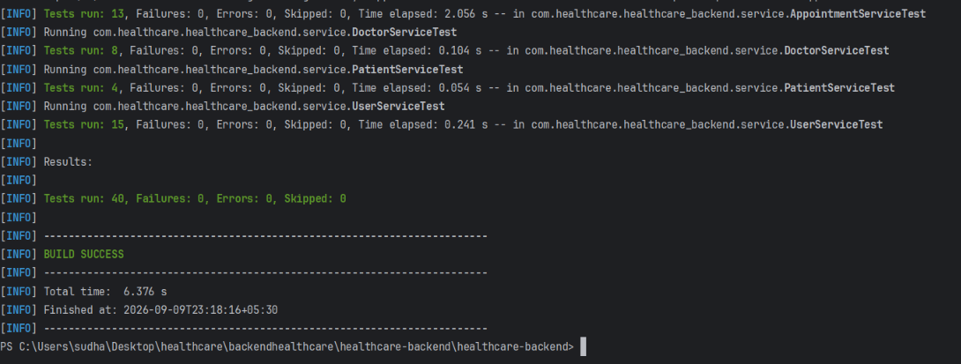
2.User Registration DTO (This is to check the constraints at input)
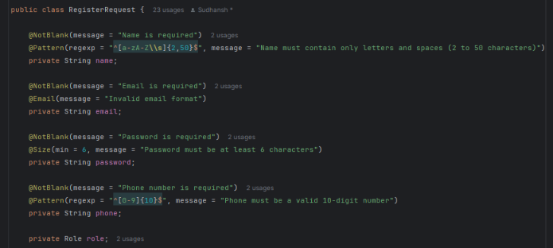
3.Appointment Request DTO (This is for appointment )
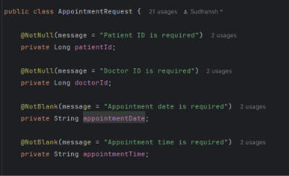
4. Global Exception Handler (This is centralized handler file for various exception)
